**COMPREHENSIVE ANALYSIS OF FINANCIAL PERFORMANCE : INSIGHTS FROM LEADING BANKING**

**SRM ARTS & SCIENCE COLLEGE**

**DEPARTMENT OF ELECTRONICS AND COMMUNICATION SCIENCE**

**RANJITH K (Leader)**

**BHARATH S**

**JANSI RANI S**

**PRANITHA S**

**INTRODUCTION**

**1.1 Overview**

The banking industry world-wide is being transformed. The global forces for change include technological innovation; the deregulation of financial services at the national level and opening-up to international competition; and - equally important - changes in corporate behaviour, such as growing disintermediation and increased emphasis on shareholder value. In addition, recent banking crises in Asia and Latin America have accentuated these pressures.

The banking industries in central Europe and Latin America have also been transformed as a result of privatizations of state-owned banks that had dominated their banking systems in the past. In this project we are trying to analysis the bank related data and able to extract some insights from the data using Business Intelligence tools. To Extract the Insights from the data and put the data in the form of visualizations, Dashboards and Story we employed Tableau tool.

Financial performance analysis includes analysis and interpretation of financial statements in such a way that it undertakes a full diagnosis of the profitability and financial soundness of the business. The financial analyst program provides vital methodologies of financial analysis.

The previous studies discussed in the literature review have reflected that financial performance is a critical factor for the growth and stability in the banks, and then the banks looking for increasing their financial performance through several factors the current study assumes financial performance influenced by customer response and operations management.

**1.2 Purpose**

Financial performance analysis includes analysis and interpretation of financial statements in such a way that it undertakes a full diagnosis of the profitability and financial soundness of the business. The financial analyst program provides vital methodologies of financial analysis. The importance of financial statement analysis is a critical tool for businesses to evaluate their financial health. Knowing the importance of financial statement analysis that help to get a information on a company's financial performance, including its profitability, liquidity, solvency, and efficiency.

A company's financial performance tells investors about its general well-being. It's a snapshot of its economic health and the job its management is doing—providing insight into the future: whether its operations and profits are on track to grow and the outlook for its stock.

To assess the structural performance, one has to study the countryside of the banks and the causes for which its performance is being assessed to properly select the applied measurement or component when determining the performance of those banks. Using the economic ratios, investors can determine the performance of a bank.

This is reliable with the statement that the comparison in the form of ratios products statistics that are more objective, for the reason that the performance dimensions can be compared with other banks' or with the prior period. The banks' performance can be seen through a wide range of variables or indicators.

**PROBLEM DEFINITION AND & DESIGN THINKING**

**2.1 Empathy Map**

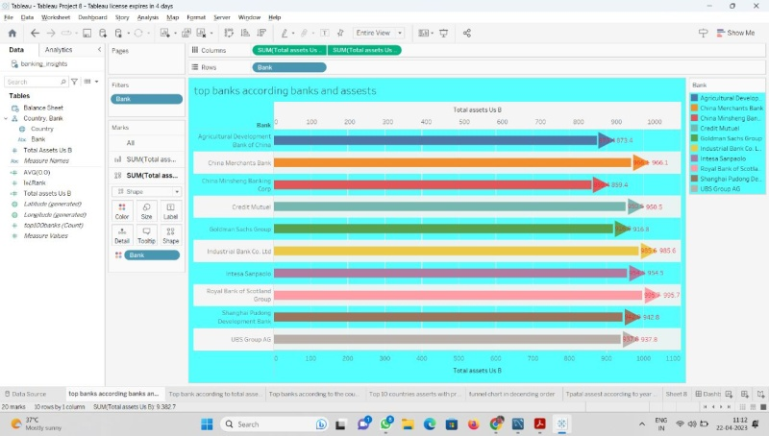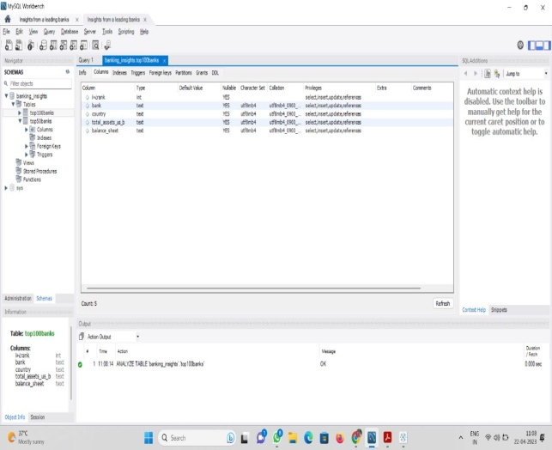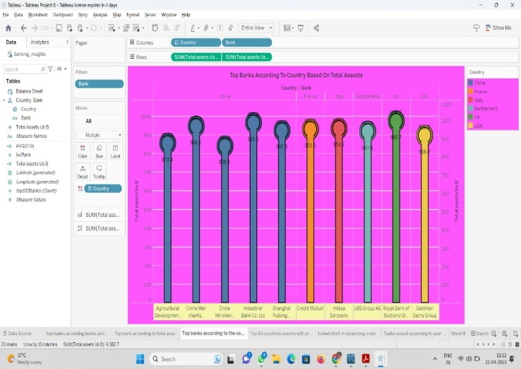

**2.2 Ideation & Brainstorming Map**

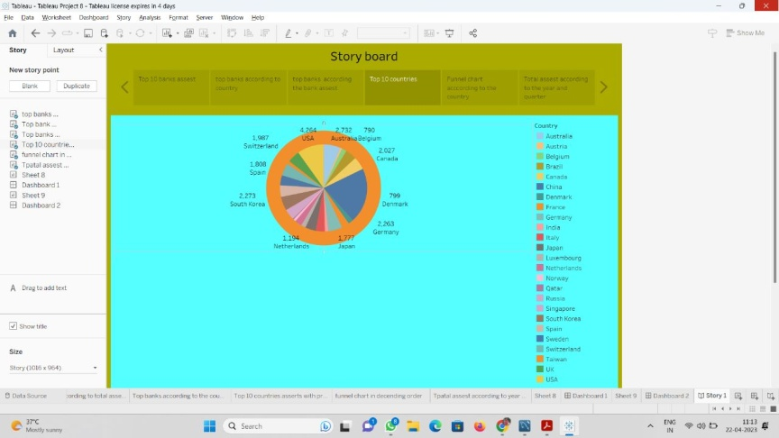

**RESULT**

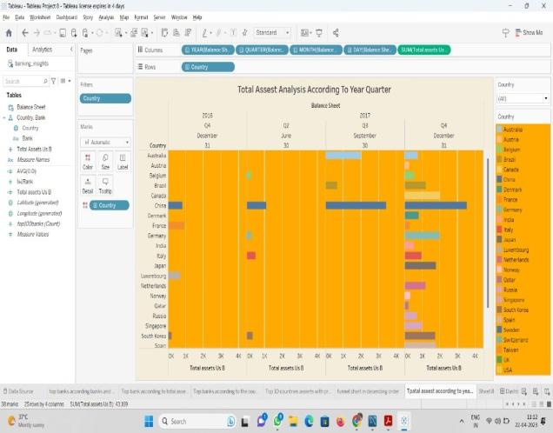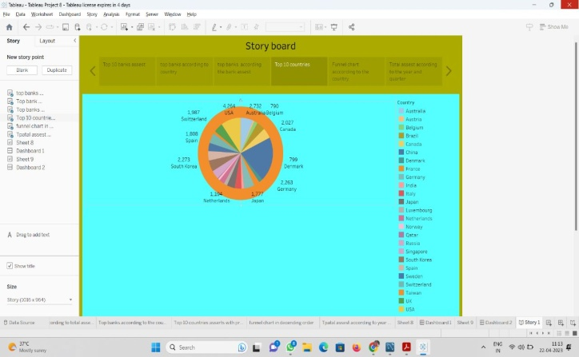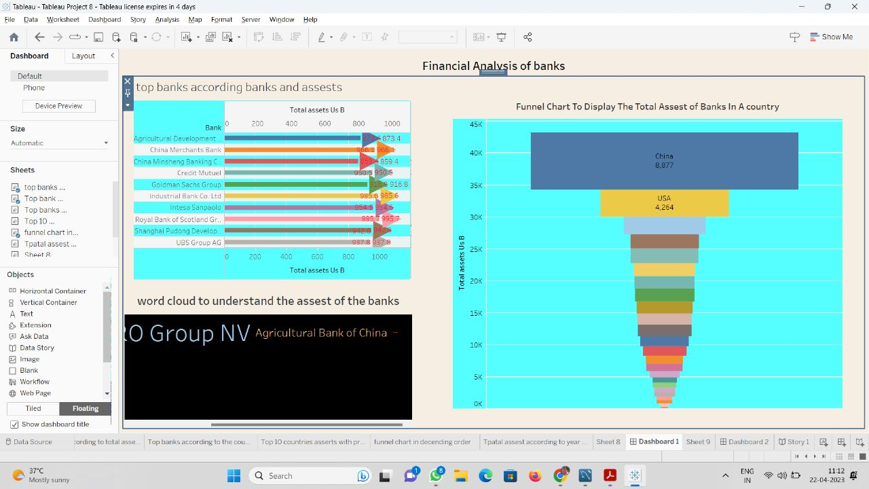

**ADVANTAGES & DISADVANTAGES**

**Advantages:**

* Monitoring your financial performance therefore creates more certainty and confidence in making both short and long term decisions. This in turn leads to a healthier business and faster growth rate. It also allows you to outperform and outmanoeuvre competitors who fail in this regard.
* Understanding how banking and big data work in practice requires familiarity with the technologies used to collect, clean and analyze the data sets of information gathered from a variety of channels.
* The financial services industry was among the first to adopt big data analytics and use it in strategic planning to identify market trends and gain an advantage over the competition. Predictive analytics allows for faster movement and long-term planning to decide what types of products to offer customers and when to offer them. AI, specifically, helps drive this proactive strategy, prevent banking customer churn and promote best actions when it comes to retail.
* Data analytics can also identify opportunities for cross selling, allowing banks to better bundle services and create product packages that appeal to customers at specific points in their lives. Consumers on the verge of buying a home, growing their family or investing their money can be identified and targeted with specific verbiage and visuals.

**Disadvantages:**

* Analytics can be used to identify and rate individual customers who are at risk of fraud and then apply different levels of monitoring and verification to those accounts. Analyzing the risk of the accounts allows banks and financial institutions to know what to prioritize in their fraud detection efforts.
* Risk modeling is the process of simulating how a portfolio of assets (stocks, bonds, futures, options, etc.) or a single asset (such as an interest rate) moves in response to different scenarios**. When risk modeling is done correctly and consistently across all assets, you can reduce your portfolio's overall risk and improve its performance.**
* Credit risk analysis of Banks and financial institutions use analytics to manage the risk associated with the loans they make. This is done by monitoring data they collect on individual customers.
* The biggest negative impact of technology is loss of jobs as automation has replaced number of jobs in banking sector. As the banking sector is increasing their dependency of work on technology, the need of manual task has decreased exponentially.

**APPLICATION**

* Among the key financial ratios, investors and market analysts specifically use to evaluate companies in the retail banking industry are net interest margin, the loan-to-assets ratio, and the return-on-assets (ROA) ratio.
* Capital adequacy ratio (CAR) It is the measure of a bank's available capital divided by the loans (assessed in terms of their risk) given by the bank. ...
* Gross and net non-performing assets.
* Provision coverage ratio.
* Return on assets. .
* CASA ratio.
* Net interest margin.
* Cost to income.
* One of the most important KPIs for banks, net interest margin (NIM) reveals a bank's net profit on interest-earning assets, such as loans or investment securities. Since the interest earned on these assets serves as a primary source of revenue for a bank, this metric can indicate a bank's overall profitability.

**CONCLUSION**

A Financial Performance Report is a summary of the Financial Performance of a Company that reports the financial health of a company helping various investors and stakeholders take their investment decision. Analysis of financial statements is extremely important for every business to grow and increase their revenue. It should not be compromised since it increases the efficiency of business operations. Better processes and expert analysts can help in the detailed analysis process. The primary and most important objective of financial management is to maximise the return on investment (ROI) in a way that fulfils the objectives of any firm while keeping the risks under control.

**FUTURE SCOPE**

* Analyze financial ratios to assess profitability, solvency, working capital management, liquidity, and operating effectiveness. Compare current performance with historical conditions using trend analysis. Compare with peer companies or industry averages to find out how well companies are performing
* The banking sector mainly recruits for three posts- Clerical cadre, Management and Trainee (MT), and Probationary Officer (PO). Other opportunities in this career path are Financial Service Representatives, Bank tellers, Bill and Account Collectors, Loan Officers, Financial Managers, Bookkeeping, and Audit Clerks.
* The complete analysis of every relevant aspect of a company's financial operations. The goal of such analysis is to provide a complete picture of the financial status of a company both in the current time and projected into the future